Building Community Library Network

Screenshot 1
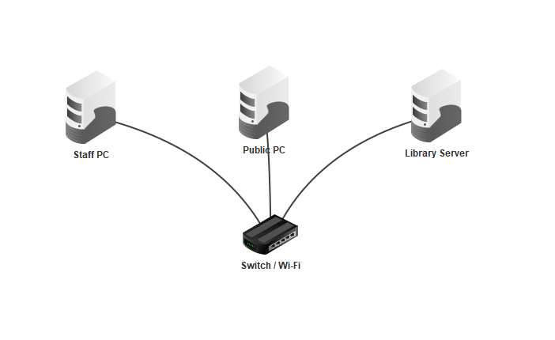
In this network, the Staff PC acts as the client and the library server acts as the server. The Staff PC sends requests to the server over the network, such as a ping or web request and the server responds. This shows a client-server relationship where one computer requests a service, and another provides it.
Screenshot 2
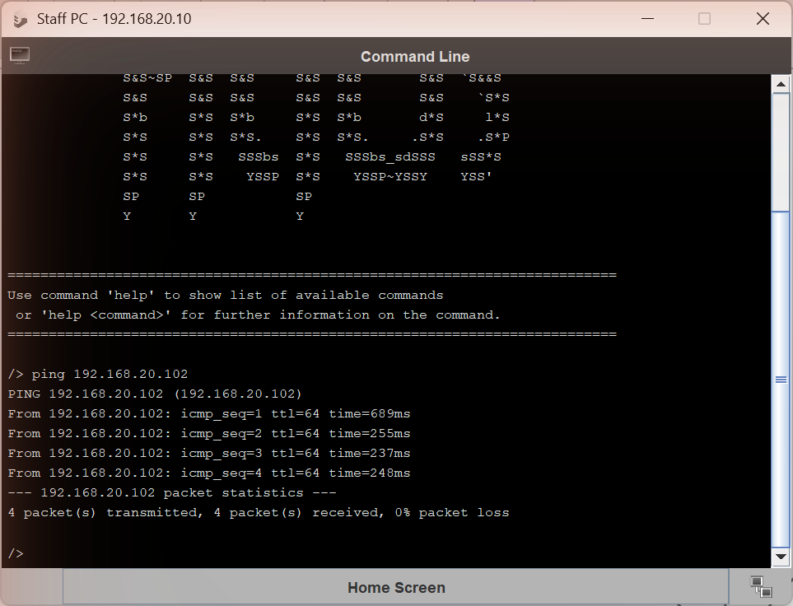
In the command line, I pinged the IP address of the library server to check if the packets would be received.
Screenshot 3
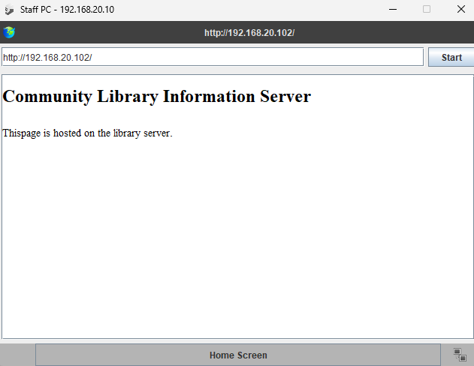
On the web browser, I searched up the IP address of the library server to see if the community page would appear.
Protocol | Screenshot | Top Layer reached | One-line: what it did
ARP |  | Internet | Resolves an IP address to a MAC address on the local network
ICMP |  | Internet | Used ping requests and replies to check that the server was reachable
TCP |  | Transport | Established a reliable connection between the Staff PC and the Library Server
HTTP |  | Application | Sent a GET request for the webpage and received the HTML page from the server
DNS | None |  | Translates a domain name into an IP address

“Why did ping use fewer layers than loading the web page?”
Ping uses fewer layers because it does less in comparison than a loading web page as it only needs to check whether the server is reachable using ICMP, a loading web page needs a reliable TCP connection and an HTTP application request, so it moves further up the network stack through encapsulation.

